**Learning activity 2-10**

**1.- We want to design a database that gives us information about the Autonomous Communities and provinces of Spain.**

*For each Autonomous Community we can obtain the provinces that make it up, the capital, the number of inhabitants and the presidents it has had. Of all the presidents that each community has had, we will know which one is the current one.*

*From each province we can obtain its inhabitants.*

We have already made the conceptual design using the following E/R diagram. Carry out the logical design of the database using a relational diagram resulting from transforming the E/R diagram.

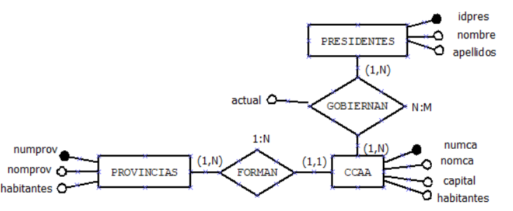

**2.- We want to design a database that gives us information about soccer teams that participate in a competition.**

*Soccer teams have a full name, an abbreviated name, two contact telephone numbers and a Web address. Both the website and the second phone with non-mandatory attributes. You must be able to know the stadium of each team, its name, address and capacity. You must be able to know the players that each team has or has had, name, surname, aliases, positions. If you currently play on the team, that information must be recorded.*

We have already made the conceptual design using the following E/R diagram. Carry out the logical design of the database using a relational diagram resulting from transforming the E/R diagram.

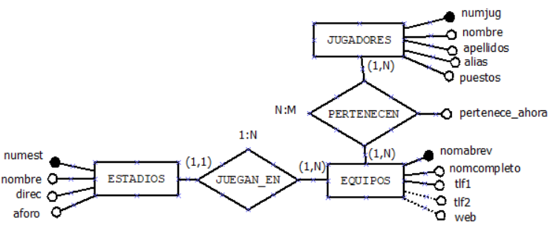

**3.- We want to have a database to manage the results and classification of a basketball league.**

*For each team, you have its name, code, pavilion in which it plays, and president.*

*You must be able to obtain the result of any match.*

*It must be possible to obtain the points that each team has and therefore have a classification.*

We have already made the conceptual design using the following E/R diagram. Carry out the logical design of the database using a relational diagram resulting from transforming the E/R diagram.

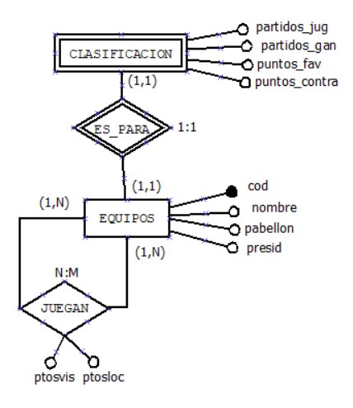

**4.- You want to have a database to manage car repairs in a workshop and the operators who participate in the repairs.****The system functionality description is as follows:**

*Car repairs (registration, make, model, kilometers) are broken down into a set of tasks characterized by type, description and duration. The tasks are carried out in different repair areas (name, zone, number). The same task can be developed in several areas.*

*Repair tasks are carried out by several workers. We want to know the operators assigned to a specific repair task as well as the repair area in which they work.*

We have already made the conceptual design using the following E/R diagram. Carry out the logical design of the database using a relational diagram resulting from transforming the E/R diagram.

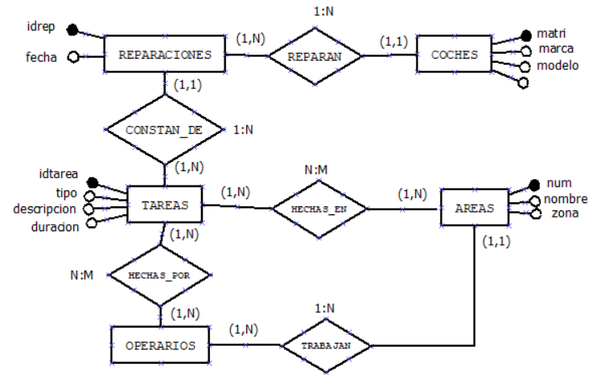

**5.- You want to have a database to control the training of a company's apprentices.****The system functionality description is as follows:**

*In a company there are specialized workers and apprentices. Of the specialized ones, we want to know their ID, name, address, NSS, years of experience and specialty. For apprentices, we want to know their ID, name, address, SSN, start date of the learning period and operator responsible for their learning period.*

*Trainees attend training courses (code, name, duration) and in each course they are evaluated with various scores.*

We have already made the conceptual design using the following E/R diagram. Carry out the logical design of the database using a relational diagram resulting from transforming the E/R diagram.

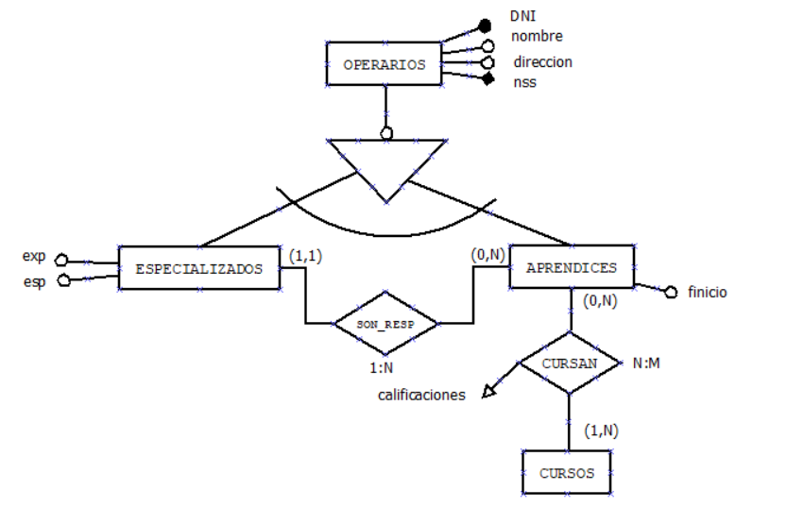

**6.- You want to have a database to manage sales in a home sales company. The functional description of the system is as follows:**

*a) There are several home sales areas for a sales company. Each salesperson is assigned to a single zone (number, name, location). Different sellers can operate in the same area, each selling a certain group of products exclusively.*

*b) There are several groups of products (code, type). Sellers can sell more than one group of products. Products are characterized by a code, a name and a price. Each product belongs to a single product group.*

*c) Information is saved on the date on which a seller makes the sale of a product by recording buyer data, date of sale, units sold.*

We have already made the conceptual design using the following E/R diagram. Carry out the logical design of the database using a relational diagram resulting from transforming the E/R diagram.

